Git and Git hub task – 02
- Installing git

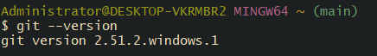
If it prints a version, Git is installed.
2. Create a repo in github with README.md and .ignore file.
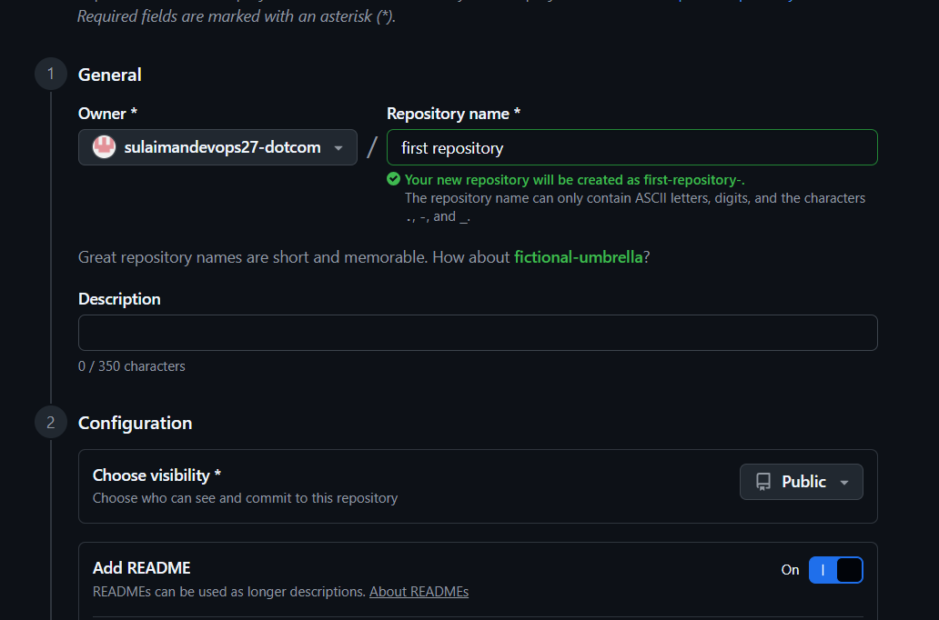
We create our first repository

3. Clone the created repo to local
First we need to copy the url the paste on terminal for example
Git clone ( your url )
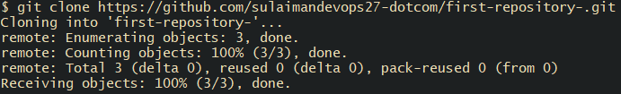
You see been clone our url
4. Create two files in local repo
cd repo-name ( your repo name )
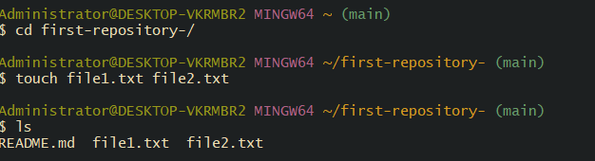
You see we have two files 1 and 2 . txt
5. Commit two files and push to central Repository
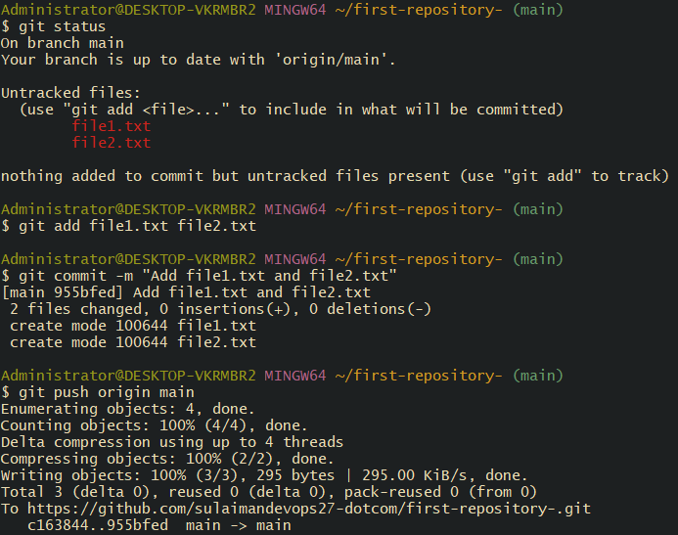

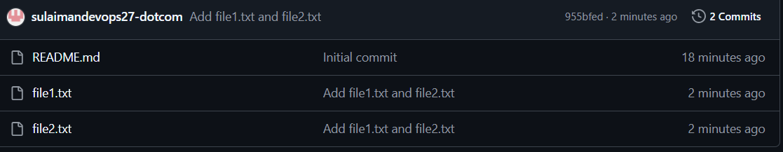

You notice we add our 2 file on github with simple commands
( git add ) = tells Git to track these files and include them in the next commit.
( Git commit -m ) = adds a commit message describing the changes.
(Origin) = is the remote repository (your GitHub repo).
(Main) = is the branch you are pushing to (replace with your branch name if different).
6. Create a branch in local and create a sample file and push to central.
Create and switch to a new branch
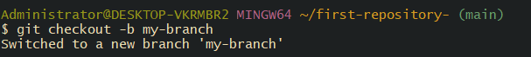
my-branch = is the name of your new branch (you can name it anything).
-b = creates the branch and switches to it immediately.

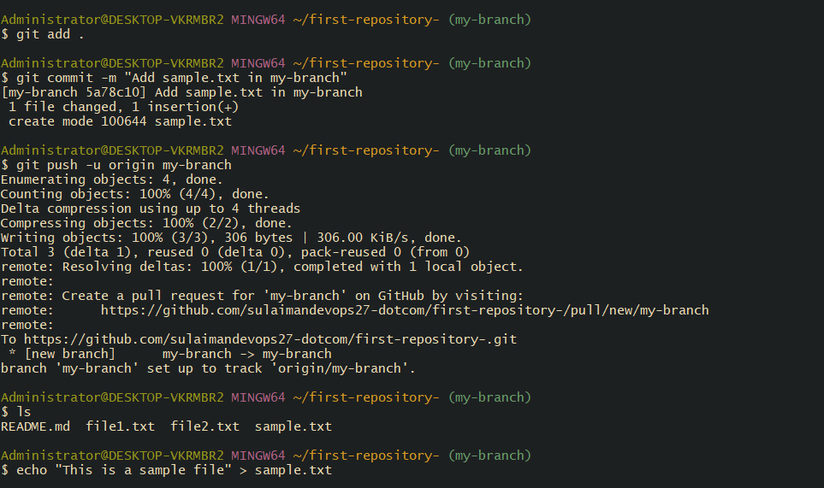
You see we have been add our sample.txt
7. Create a branch in github and clone that to local.
Create a branch on GitHub
First click on branch drop box usully say main
Type new branch name in my case type my branch-name ( github-branch)
Then press enter it create ur branch

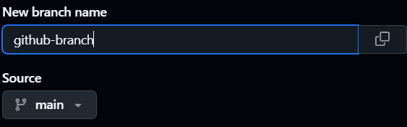

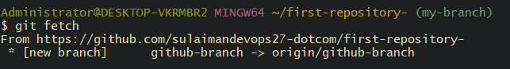
Command = ( Git fetch )
Update ur local git
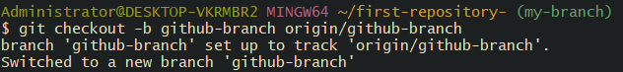
-b github-branch creates a local branch with the same name. origin/github-branch tells Git to track the branch from GitHub.
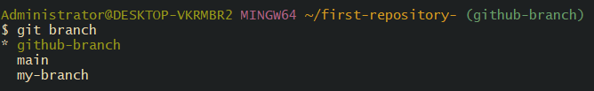
Now we successfully create branch in github and clone

8. Merge the created branch with master in git local
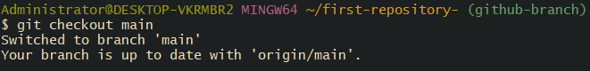
You must be on the branch you want to merge into (main in this case).
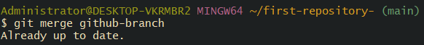
Replace github-branch with the name of the branch you want to merge.
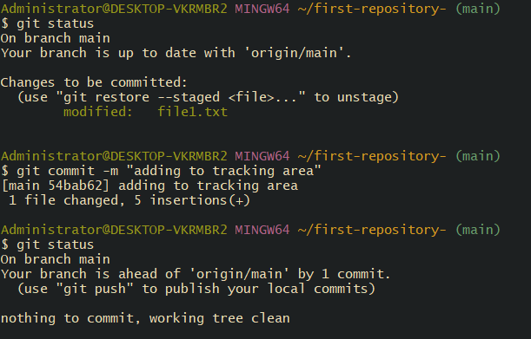
Now we marage our file successfully
- Merge the created branch with master in github by sending a pull request.

Go to your GitHub repository
Open your repository in a browser.
You should see your branches listed (e.g., main, github-branch, feature-branch).

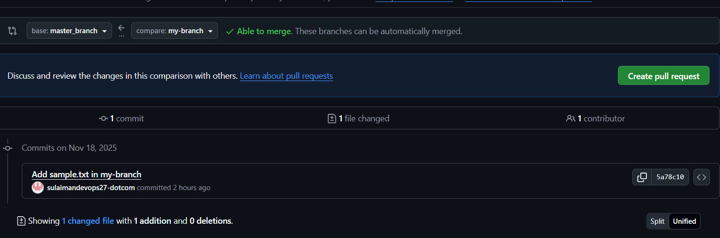
Start a Pull Request
- Click on Pull Requests tab.
- Click New Pull Request.
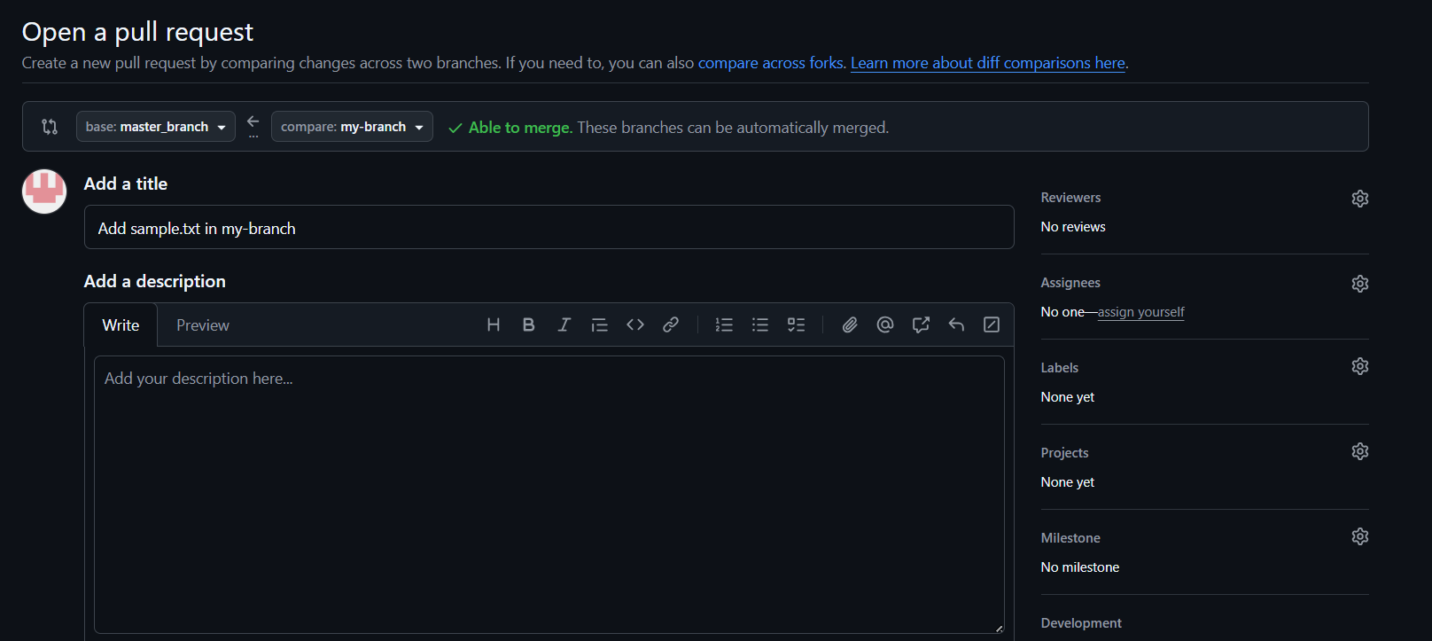
Step 3: Select branches
- Base branch: main → This is the branch you want to merge into.
- Compare branch: github-branch (or whichever branch you want to merge from).

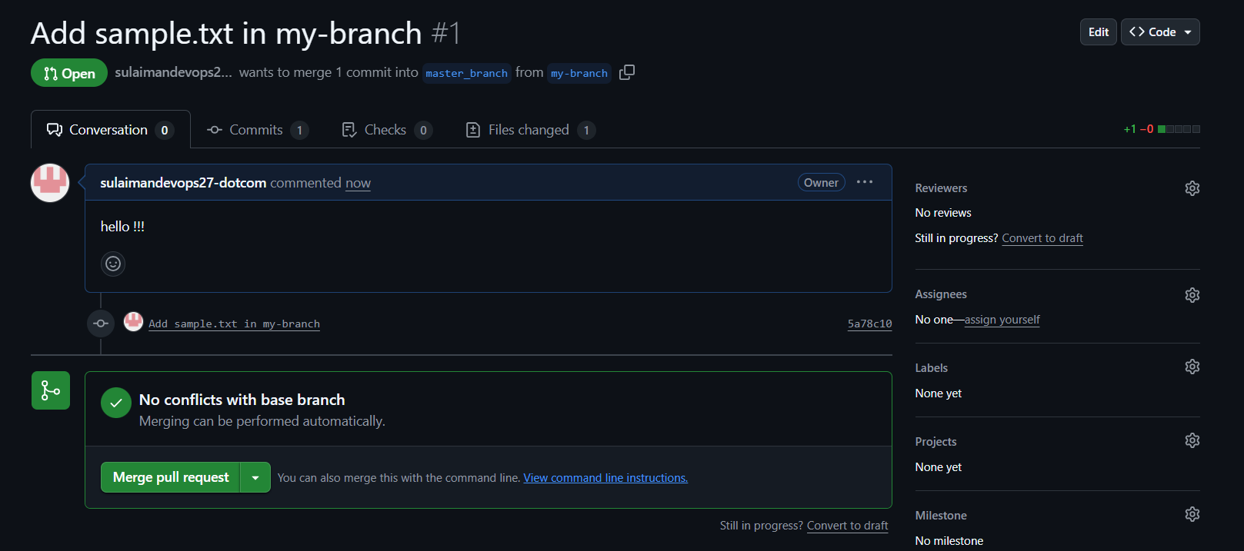

Step 4: Create the Pull Request
- Click Create Pull Request.
- Add a title and description if you want (optional).
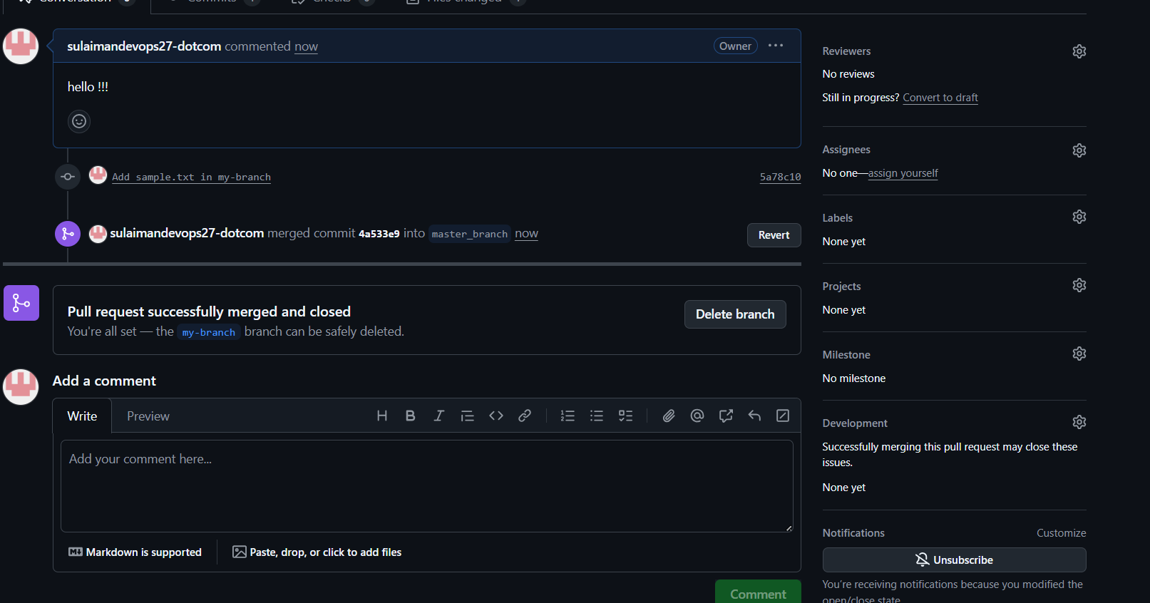
You see our pull request successfully completed
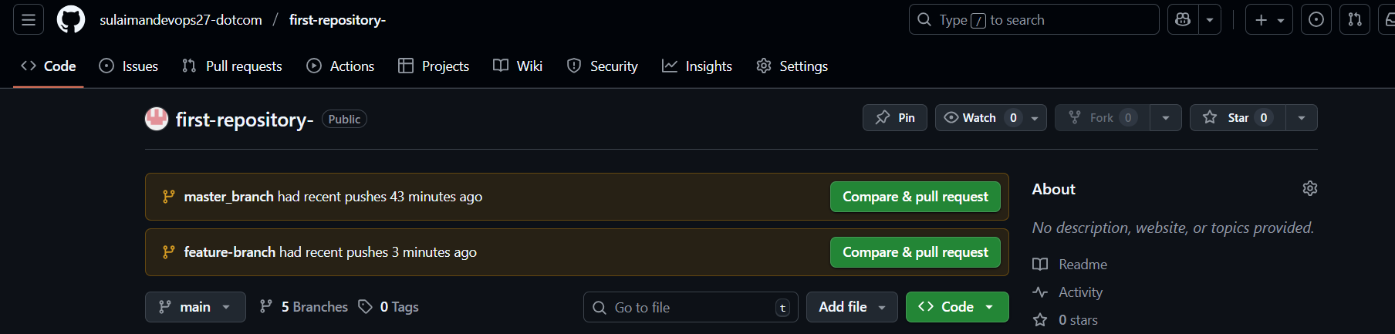

This few steps to create to pull request
10.Create a file in local and send that to branch in github.

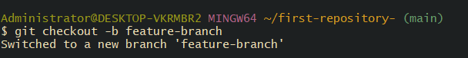
feature-branch is the name of your new branch (you can name it anything
-b creates the branch and switches to it immediately.
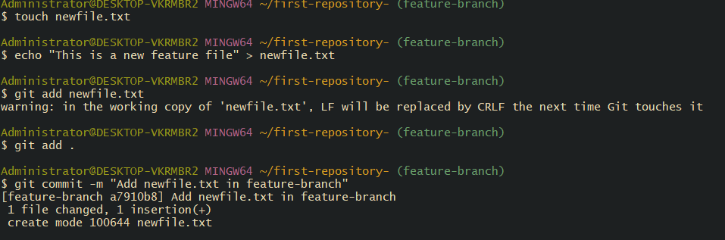
This few command we use in that
This tells Git to track the file and include it in the next commit.Or, to add all changes at once:
-m adds a commit message describing your changes.
-u sets the upstream, so next time you can just do git push.
This will create the branch on GitHub if it doesn’t exist yet and push your file.
Create a new file
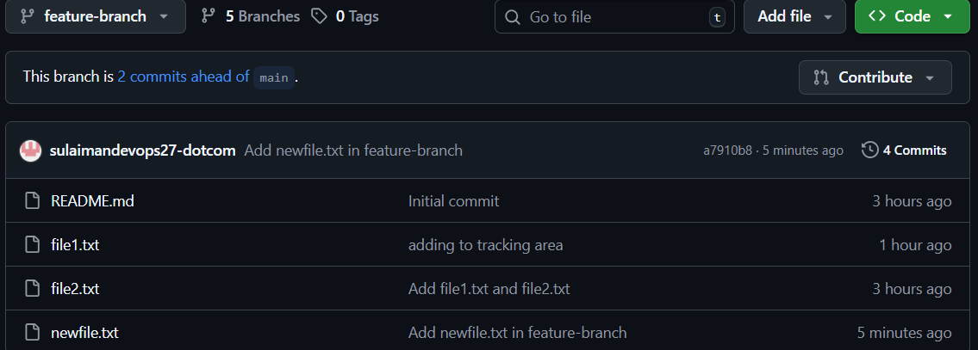
Now successfully create newfile.txt in repo
11. Clone only a branch from github to local.
Get the branch name in my case im going to feature-branch
And then clone it
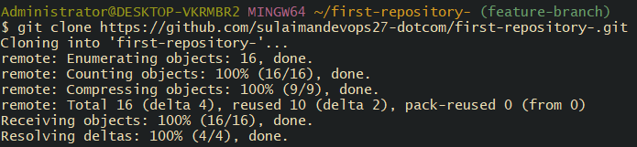
We have clone it
Now go to ur Desktop using simple ( cd ~/Desktop)
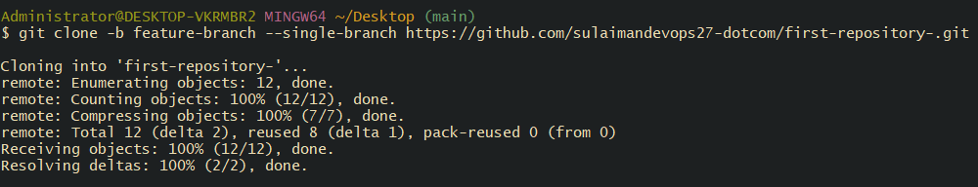
Use command “git clone -b (branch name) ssh url”
Branch name Testing and copyed ssh url from remote repository.
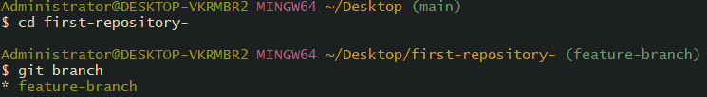
Now goes repository ( cd ur repo name )
* shows the branch you are currently on.
Then type git brach you seeing down message *feature-branch it means successfully cloned only one branch from GitHub to your local machine.
12. Create a file with all passwords and make that untrackable with git.
his creates a new file called passwords.txt in your local repo.
If have this gitigmore ignore if don’t have follow me
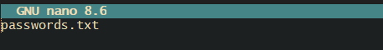
Then write this passwords.txt then press ctrl+o enter ctrl+x
If passwords.txt was already added to Git before, you need to remove it from tracking:
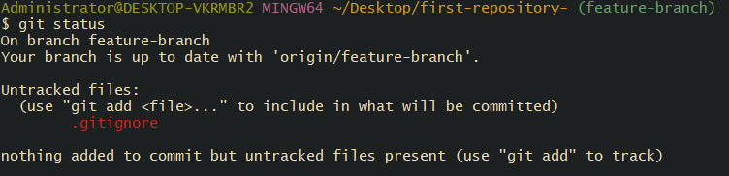
You should see no mention of passwords.txt in changes to be committed.
Git will now ignore this file in future commits
Now your passwords file exists locally but is completely untracked by Git, keeping your secrets safe
13. Make a commit and make that commit reset without savings changes.
create a temporary file:

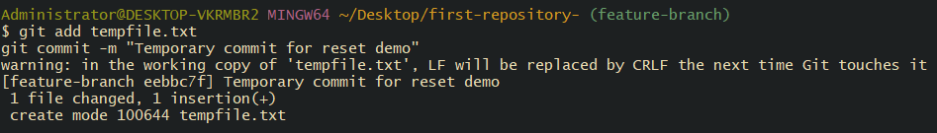
This creates a commit in your local branch.
HEAD~1 → refers to the previous commit.
The changes from the commit stay in the staging area.
The changes stay in your working directory but are unstaged.
Now create file ( tempfile.txt)

Commit the changes

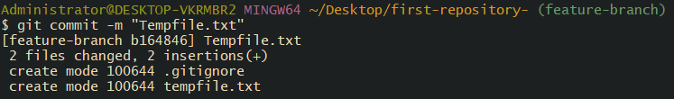
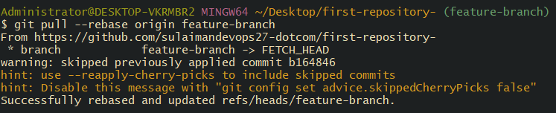
Since your local branch is behind, do a rebase pull:

Push to GitHub
NOW we have branch will be synchronized with GitHub and all files will be tracked.

13 Make a commit and make that commit reset without savings changes.
This creates a new file demo.txt with some content.
This tells Git to track the file for committing.
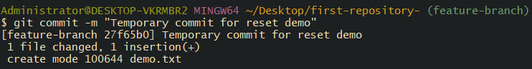
Now Git has a commit you can reset.
emoves the commit but keeps the changes staged (ready to commit again).
Removes the commit and keeps changes in the working directory unstaged.
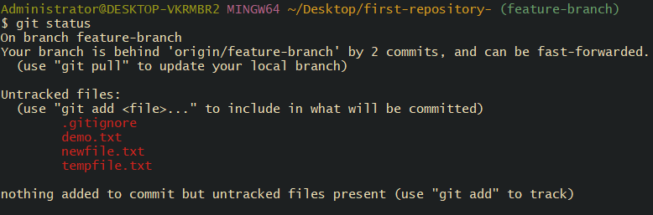
We have successfully completed commit and make that commit reset without savings changes
- Revert a commited commit to the older version.
git status = Check your current branch and status
git add . = Stage any untracked files if you want to save them
git commit -m "Temporary commit to clean working directory" = Commit temporarily to clean working directory (optional if you staged files)

git pull --rebase origin feature-branch = Pull remote changes (optional but recommended)

git log –oneline = Check commit history to find the commit hash to revert

# Example output:
# d3afae6 Add demo.txt and tempfile.txt
# a7910b8 Previous commit
# 54bab62 Older commit

git revert d3afae6 = Revert the desired commit safely

git push origin feature-branch= Push the revert commit to GitHub

git log --oneline
git status = Verify the revert

THIS are steps revert a commited commit to the older version

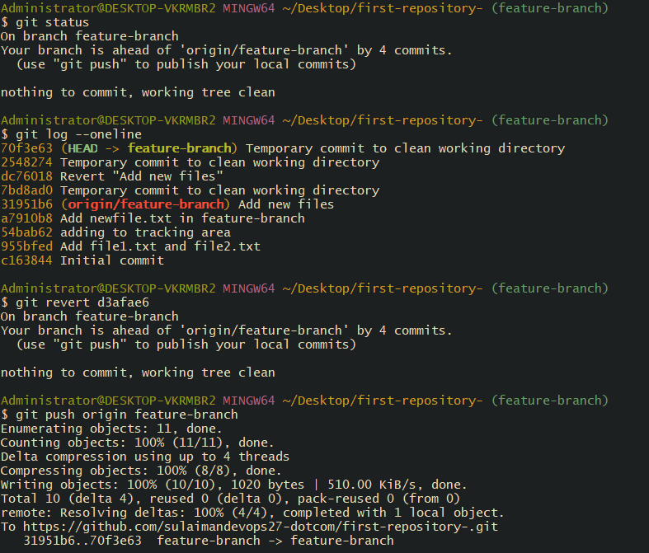

15. Push a file to stash without savings the changes and work on another file.
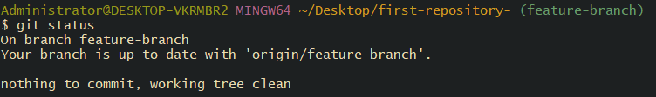
Make sure you’re on the correct branch (e.g., feature-branch) In my case its feature-branch
-u → includes untracked files (like a new file).
-m "..." → gives a name to the stash for easy identification.
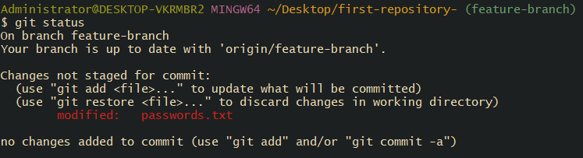
Its means your working directory is now clean.

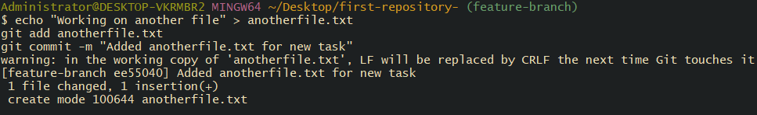
This does not affect the stashed file, which is safely stored.
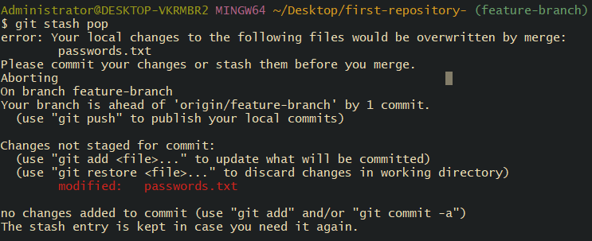
now we succefully . Push a file to stash without savings the changes and work on another file.

16. Undo the stash file and start working on that again.
Each stash has a number (stash@{0}, stash@{1}, etc.)
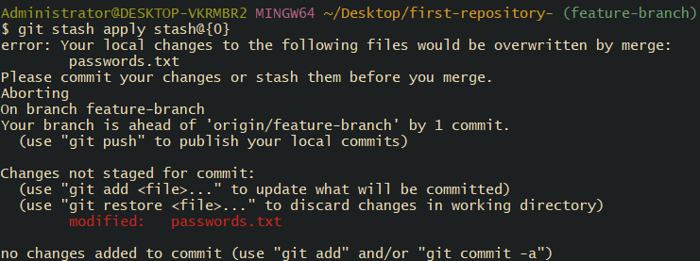
This restores the stashed file into your working directory but keeps the stash in the list so you can reuse it later.
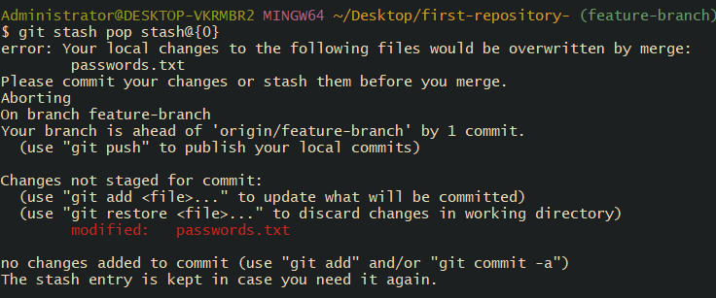
This restores the stashed file and removes it from the stash list.If you get an error like:
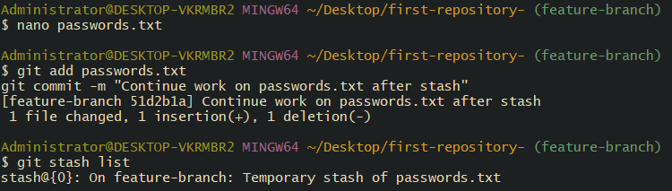
Once the stash is applied or popped, the file is back in your working directory.
Edit the file as needed:
17. commit the chaGenerate a ssh-keygen and configure into github. Nges
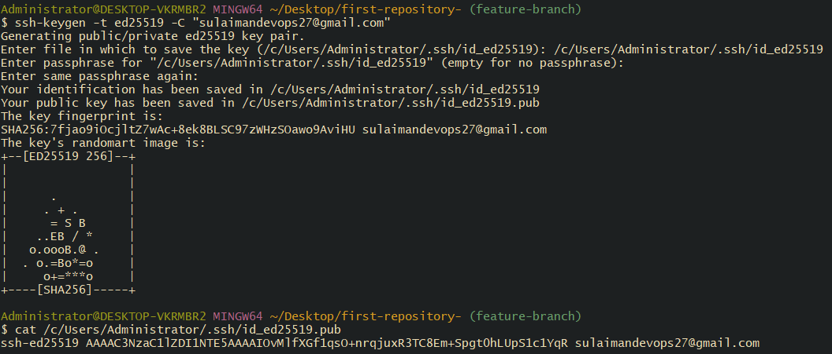
generate our ssh-keygen
now go to github setting find key then follow this steps
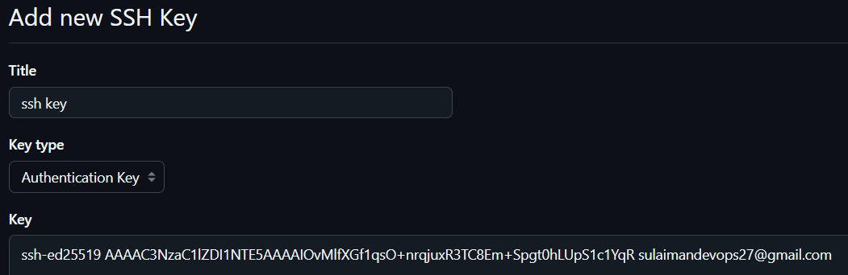
Now gennrate ssh key
Now your SSH key is configured and you can push/pull via SSH instead of HTTPS.
19. Basic understanding of .git file.
What is the .git folder?
The .git folder is created when you run git init in a directory.
It stores all the metadata and history of your Git repository.
Without .git, your folder is just a normal folder — Git cannot track changes.
.git = brain of your repository.Stores history, branches, commits, config, and everything Git needs.Don’t delete or manually edit it unless you are advanced.
20. Check all the logs of git.
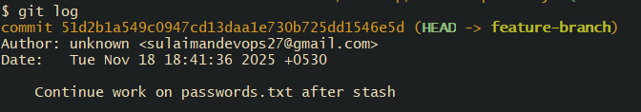
Shows all commits in your current branch in reverse chronological order (newest first).

21 Rename the commit message.

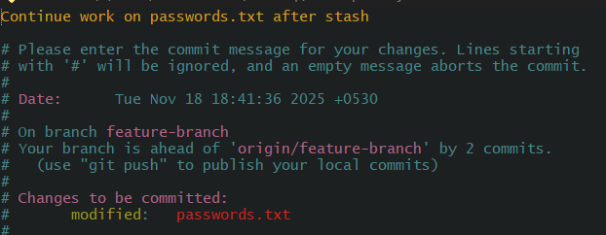
Using command: git commit –amend. Change or rename the message and exit

22. Merge multiple commits into single commit.

